Prompt – 1 = Here, one more tracker we are maintaining, which is called as daily leads tracker. And I will explain what the tracker is going to have. The daily leads tracker is having two sheets. So, in first sheet, it's showing about the positives. Second sheet is showing about the daily received. So, how we are monitoring means, in the first sheet, we used to monitor the company details as usual, like serial number, timestamp, company name, role, CTC, batch, college name. And we are maintaining it daily. We are maintaining it daily. So, that particular table is going to have for the day, if we are having total 15 active colleges, so what are all the positives attended by those 15 active colleges. This need to be completely manually updated only by the placement coordinators. It can be viewed by admins and team leaders. I have attached the sample screenshot of this for your reference and then coming to the job description received sheet As per the screenshot 2 it is dealing with the job description received so how this is monitored means we are sending the invitation email and we are waiting for few days and following up on remaining the hour and asking for job description finally successfully after 10 days we are receiving the job description let us assume so immediately in this job description sheet we will be updating as per the details mentioned in the screenshot serial number company name company role and CTC badge and for what college we received at what time the email is received in the inbox so these these also completely manual work there is no automation there is no automatically picking up the task So because it's having the time stamp we have to completely do it manually Either we can copy it from the daily tracker weekly trucker and paste it here anything is fine but this is a manual work and only editable by placement coordinator not by admins and training leaders I mean team leaders So we are having these two extra task daily tracker weekly tracker After that we are having this tracker It is not a separate attacker but we are maintaining it in a separate Excel sheet For regular basis So my question is where we can add this So we are having so many sections so this is named as daily leads section when I click on the daily leads tab it need to list me first positives for the day college wise And then I am having drop down box where I can click the college and see the positives with the timestamps and details role in CTC And then the same excel look is having two tab 1 tab is on the screen I am telling sidebar is having daily leads on the viewing centre Console area I'm having Positives for the day and day job description received JD received section we casually say like that So how we are going to design it how we are going to plan it where we are going to locate but definitely daily leads is a separate section like daily trucker weekly tracker
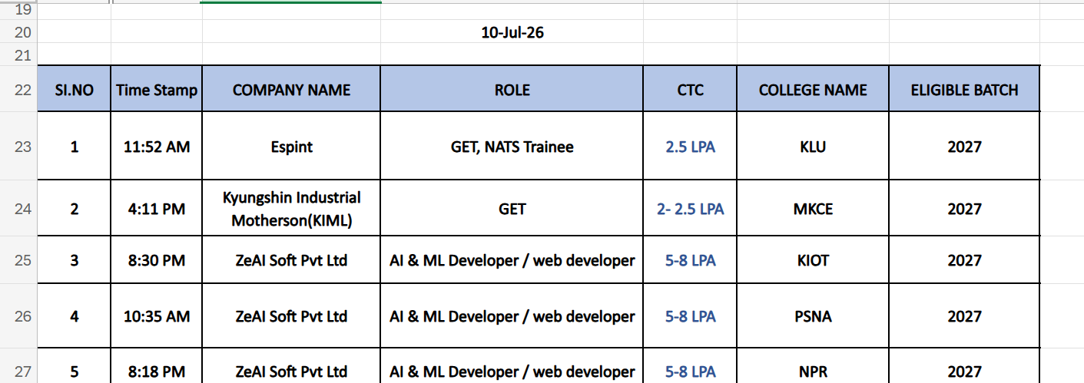
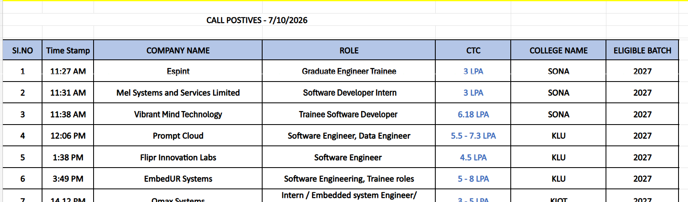

Response 1 - I actually think you've uncovered something important here. This should not be merged into the Daily Tracker or Weekly Tracker. It deserves to be a separate operational module, because it serves a completely different business purpose.
Here's how I see the distinction:
- Daily Tracker → Tracks communication activities (calls made, call outcomes, remarks).
- Weekly Tracker → Tracks the lifecycle of companies (pipeline, progress, completed, rejected).
- Daily Leads → Tracks the positive opportunities generated each day and the Job Descriptions (JDs) received.
These are three different business processes, so keeping them separate will make the system much cleaner.

Proposed Module Structure
Instead of jumping directly to Reports & Analytics, I would insert one more operational module.
Module 1 – User Management ✅
Module 2 – Master Company Database ✅
Module 3 – Daily Tracker ✅
Module 4 – Weekly Tracker ✅
Module 5 – Daily Leads 🆕
Module 6 – Reports & Analytics
Module 7 – Role-Based Dashboard
Module 8 – Notifications
Module 9 – Settings
Module 10 – Audit Logs
I think Daily Leads is a better name than "Daily Leads Tracker" because it's shorter and consistent with the other modules.

Purpose of Module 5 – Daily Leads
This module answers two operational questions:
- What positive opportunities did we receive today?
- What Job Descriptions (JDs) did we receive today?
It is a daily operational register, not a workflow.

Sidebar Navigation
Dashboard

User Management

Master Company Database

Daily Tracker

Weekly Tracker

⭐ Daily Leads

Reports & Analytics

Settings

Daily Leads Screen
I would avoid creating two sidebar menus ("Positives" and "JD Received"). Instead, keep one menu called Daily Leads.
When the user clicks it, the content area can have two tabs, just like Excel sheets.
──────────────────────────────────────────────

Daily Leads

[ Positives ] [ JD Received ]

──────────────────────────────────────────────
This will feel familiar to users because it mirrors how they're already working.

Tab 1 – Positives
Columns:
S.No | Time | Company | Role | CTC | College | Eligible Batch
Toolbar:
- Date Picker
- College Filter
- Search
- Export Excel
- Add Row
Everything is manually editable by the Placement Coordinator.
Admins and Team Leaders have read-only access.

Tab 2 – JD Received
Columns:
S.No | Time | Company | Role | CTC | College | Eligible Batch
Exactly the same structure.
The difference is the meaning of the data.
This table records companies from whom the Job Description has actually been received.

Daily Filter
At the top:
Date

10 Jul 2026

▼
Changing the date instantly shows the entries for that day.

College Filter
Next to the date:
College

All Colleges ▼
Options:
- All Colleges
- SONA
- KLU
- KIOT
- PSNA
- NPR
- etc.
If "All Colleges" is selected, the table displays records from every active college.
If "KLU" is selected, only KLU records are shown.

Why I Prefer Filters Instead of Separate Tables
Imagine you have 15 active colleges.
Creating 15 separate tables would be impossible to manage.
One table + filters is much cleaner and scales better.

Permissions
Role | Permission
Placement Coordinator | Full Add/Edit/Delete
Team Leader | Read Only
Administrator | Read Only
Training & Placement Officer | Read Only
This exactly matches your current process.

Future Enhancement
One thing I think will save time later is a "Copy from Daily Tracker" action.
Suppose you've already entered a company in the Daily Tracker.
Instead of typing everything again:
Add Row

↓

Copy From Daily Tracker

↓

Search Company

↓

Select

↓

Fields auto-filled

↓

Save
The coordinator only needs to confirm the entry.
This is optional and doesn't remove manual control—it just reduces repetitive typing.

My Recommendation
I would not automate this module.
You've already explained why:
- Some positives come through calls.
- Some come through email.
- Some come through WhatsApp.
- Some are entered later.
- The timestamp itself is manually recorded as part of your process.
Trying to automate it would make the process less reliable.
So I would intentionally design Daily Leads as a manual operational register with fast data entry, filtering, and exports, rather than trying to synchronize it automatically.
One Small Improvement
The only enhancement I would add is a small summary strip above the tabs:
Date: 10 Jul 2026

Today's Positives: 18

Today's JDs Received: 7

Active Colleges: 15
This gives an immediate overview without opening reports, while keeping the detailed records in the two tabs below. I think this complements your existing Excel workflow without changing how your team operates.

Prompt 2- So the tab on POST is going to have serial number, time when the JD is shared, date when the JD is received. If the date picker is going to give time and date means, fine. If it is not going to give time and date together, means we need extra one column, date. Rest all columns are good. So hence everything is manually editable by placement coordinator. Admin team, it has have only read-only access. They cannot edit it. So if they want to edit completely means, they can tell the placement coordinator to change. Similarly for tab to JD received also, we need a date column. On what date the JD received. And obviously we are having the daily filter on what date we want to see the postings. Good. College filter is also there, very good. And yeah. So whenever they type the entries or they copy from the daily tracker unplugged here in daily leads whatever option is feasible When they click enter that particular row is saved in the daily leads for the day by that placement coordinator So here in this daily leads all the placement coordinators are involved So there should be no synchronisation lagging of navigating pages and reloading the pages it perfectly be smooth enough within a fraction of seconds the task need to be done The performance need to be faster and feasible Obviously the small improvement which you are suggesting to add a small sum best trip above the tabs is definitely good idea we can do it So that's all for the daily leads do you have any doubts regarding this module 5 then we can complete this module 5 and we can move to another section that I have personally in Website creation

Response 2 - I think Module 5 is now almost completely defined. From what you've explained, I don't have any major doubts left. I would just like to formalize the design so that when we move to Cursor AI, there is no ambiguity.

✅ Module 5 – Daily Leads
Status: Business Design Completed (Version 1.0)
Purpose
To maintain a daily manual record of:
- Positive Opportunities Received
- Job Descriptions (JD) Received
This module is completely independent of the Daily Tracker and Weekly Tracker.

Sidebar
Dashboard

User Management

Master Company Database

Daily Tracker

Weekly Tracker

Daily Leads

Reports & Analytics

Settings

Daily Leads Layout
---------------------------------------------------------
Daily Leads

Date: [10-Jul-2026 ▼]

College: [All Colleges ▼]

Today's Positives: 18
Today's JDs Received: 7
Active Colleges: 15

---------------------------------------------------------

[ Positives ] [ JD Received ]

---------------------------------------------------------

Tab 1 – Positives
Columns:
S.No | Time | Date | Company | Role | CTC | College | Eligible Batch
Time & Date
I agree with your decision.
If the Date-Time Picker supports both:
10-Jul-2026 11:42 AM
then one column is enough.
Otherwise:
- Time
- Date
will be maintained as two separate columns.

Tab 2 – JD Received
Columns:
S.No | Time | Date | Company | Role | CTC | College | Eligible Batch
The structure is intentionally identical to the Positives tab, making data entry consistent.

Data Entry
Placement Coordinators can:
- Add
- Edit
- Delete
- Copy from Daily Tracker (optional shortcut)
- Manually enter everything
When they press Enter or Save, the row is stored immediately in the selected tab for that date.

Permissions
Role | Permission
Placement Coordinator | Full Access
Team Leader | Read Only
Administrator | Read Only
Training & Placement Officer | Read Only
Only the Placement Coordinator can modify records.

Filters
Date Filter
Shows entries for a selected day.
College Filter
- All Colleges
- Individual College
The two filters work together.

Performance Requirements
This is an important non-functional requirement, and I would document it explicitly.
The module should support:
- Near-instant save operations.
- Smooth navigation between tabs.
- No visible page refreshes after saving.
- Fast filtering by date and college.
- Multiple Placement Coordinators working simultaneously without conflicts.
Since multiple coordinators will be updating throughout the day, responsiveness is a key design goal.

Summary Strip
Above the tabs:
Today's Positives

Today's JDs Received

Active Colleges
This gives users an immediate overview.

One Minor Suggestion
There is only one thing I would recommend adding.
"Created By"
Not necessarily as a visible table column, but stored in the database.
For example:
Created By:
Rajesh
or
Created By:
Coordinator ID 103
Why?
Suppose tomorrow someone asks:
"Who entered this JD?"
The system can answer immediately.
It doesn't need to appear in the UI, but I think it should be stored in the backend automatically for audit purposes. This is different from an edit history—it's simply recording ownership of the record.

Module 5 Status
I would now mark:
Module 5 – Daily Leads
Status: ✅ Business Design Completed (Version 1.0)

Overall Project Progress
Module | Status
✅ Module 1 | User Management
✅ Module 2 | Master Company Database
✅ Module 3 | Daily Tracker
✅ Module 4 | Weekly Tracker
✅ Module 5 | Daily Leads
At this stage, the core operational workflow of iPOMS is well defined. All day-to-day activities—from managing companies, recording calls, tracking placement progress, and maintaining daily leads—are covered. The next major area is Module 6 – Reports & Analytics, where we'll define how this operational data is transformed into meaningful insights, charts, exports, and management reports for different user roles.

Prompt 3 - So in this I have one doubt. Can you explain me how the daily leads layout is going to be displayed on screen? So when I am in the daily leads screen, I'm going to see the top details, and then I'm going to have two different type of section, prospects and JD digit. How this two will be displayed in the screen? Am I going to have two tab bar I can switch and I can see the things, or I'm going to have two buttons inside the screen itself, it's going to self-navigate into two screens. How does it going to work?
Response 3 - This is actually a very important UI decision because it affects how users work every day. I thought about three possible designs.

Option 1 – Two Buttons (❌ Not Recommended)
----------------------------------------------------

Daily Leads

[ Positives ] [ JD Received ]

----------------------------------------------------

Click Positives

↓

Shows Positives Screen

Click JD Received

↓

Shows JD Received Screen
Problem:
- It feels like navigating between two pages.
- Slight delay while switching.
- Doesn't feel like one module.
I would avoid this.

Option 2 – Two Separate Tables on the Same Page (❌ Not Recommended)
----------------------------------------------------

Daily Leads

Today's Summary

-----------------------

Positives Table

(20 rows)

-----------------------

JD Received Table

(15 rows)

----------------------------------------------------
Problem:
- Lots of scrolling.
- If there are 30 positives and 20 JDs, the page becomes very long.
- Difficult to focus on one dataset.
I don't think this is suitable.

Option 3 – Excel-style Tabs (✅ My Recommendation)
This is the design I recommend.
┌─────────────────────────────────────────────────────────────┐

Daily Leads

Date : 10-Jul-2026 ▼

College : All Colleges ▼

Today's Positives : 18

Today's JD Received : 7

-------------------------------------------------------------

[ Positives ] [ JD Received ]

-------------------------------------------------------------

TABLE

-------------------------------------------------------------

└─────────────────────────────────────────────────────────────┘
When you click Positives
Only the Positives table is displayed.
[● Positives] [ JD Received]

------------------------------------------------

S.No

Time

Date

Company

Role

CTC

College

Batch

------------------------------------------------

When you click JD Received
The same table area changes.
[ Positives ] [● JD Received]

------------------------------------------------

S.No

Time

Date

Company

Role

CTC

College

Batch

------------------------------------------------
Notice that the page doesn't navigate anywhere.
Only the table content changes.

Why I Prefer Tabs
It is exactly how users already think.
Today they want to enter Positives.
Tomorrow they want to enter JD Received.
Both belong to the same module.
It is very similar to:
- Excel worksheets
- Browser tabs
- Chrome tabs
Users already understand this interaction.

Even Better
We can make the tabs look modern.
────────────────────────────────────

Daily Leads

────────────────────────────────────

┌──────────────┐
│ Positives │
└──────────────┘

JD Received

────────────────────────────────────
When JD Received is clicked,
────────────────────────────────────

Daily Leads

────────────────────────────────────

Positives

┌──────────────────┐
│ JD Received │
└──────────────────┘

────────────────────────────────────
A simple sliding underline animation would make switching feel smooth without reloading the page.

The User Experience
Imagine you're a Placement Coordinator.
You open Daily Leads.
You see:
Today's Positives : 18

Today's JD Received : 5

[ Positives ] [ JD Received ]
You spend five minutes entering all the positives.
Then you simply click JD Received.
The table changes instantly.
No page reload.
No sidebar navigation.
No popup.
No confusion.
Everything stays in the same module.

My Final Recommendation
I would make the tabs look like the tabs in modern web applications (rather than old browser tabs). The interaction would be:
- Click Positives → the Positives table appears.
- Click JD Received → the JD Received table replaces it in the same content area.
- The Date filter, College filter, and summary strip remain fixed at the top.
- Only the table content changes.
This keeps the interface clean, minimizes navigation, and makes it feel like a single "Daily Leads" workspace rather than two separate screens. I think it's the most intuitive design for a module that users will interact with every day.

Excellent. I think this is the best decision. It matches modern SaaS applications (Notion, Jira, GitHub, Linear, Vercel) while still feeling familiar to users coming from Excel.
✅ Module 5 Final Design (Approved)
Sidebar
Dashboard

User Management

Master Company Database

Daily Tracker

Weekly Tracker

Daily Leads

Reports & Analytics

Settings

Daily Leads Screen
┌────────────────────────────────────────────────────────────────────────────┐
│ Daily Leads [+ Add Entry] │
├────────────────────────────────────────────────────────────────────────────┤
│ Date: [10-Jul-2026 ▼] College: [All Colleges ▼] Search 🔍 │
├────────────────────────────────────────────────────────────────────────────┤
│ Today's Positives: 18 Today's JD Received: 7 Active Colleges: 15 │
├────────────────────────────────────────────────────────────────────────────┤
│ │
│ Positives JD Received │
│ ━━━━━━━━━━━━━━━━━━━━━━━━━━━━━━━━━━━━━━━━━━━━━━━━━━━━━━━━━━━━━ │
│ │
│ (Only One Table Visible Here) │
│ │
└────────────────────────────────────────────────────────────────────────────┘
The active tab will have:
- A colored underline (Infoziant theme)
- Slightly bolder text
- Smooth left/right transition (150–250 ms)
- No page refresh
- No loading animation
- Instant switching

When "Positives" is Selected
The content area displays:
S.No | Time | Date | Company | Role | CTC | College | Batch | ⋮
The ⋮ menu includes:
- Edit
- Duplicate
- Delete
(There is no need for "Move" or "Pin to Top Companies" in this module because the records don't belong to different sections.)

When "JD Received" is Selected
The same table area changes instantly.
S.No | Time | Date | Company | Role | CTC | College | Batch | ⋮
Exactly the same layout.
Only the data changes.

Add Entry
Clicking + Add Entry opens a small popup.
The first question is:
Which type of entry do you want to add?

○ Positive

○ JD Received
After selecting one, the corresponding entry form opens.
This is simpler than maintaining two different "Add" buttons.

Filters
The filters remain fixed while switching tabs.
Date

College

Search
These filters apply to whichever tab is active.

Why This Design Is Better
From the user's perspective, there is only one module.
Daily Leads

↓

Positives

↓

JD Received
Not:
Daily Leads

↓

Go to another page

↓

Come back

↓

Go to another page
That reduces clicks and keeps users focused.

One Small Enhancement I'd Like to Add
Since Placement Coordinators will use this every day, I suggest remembering the last active tab.
For example:
- Yesterday, the user was working in JD Received.
- Today, when they open Daily Leads, it automatically opens JD Received instead of always defaulting to Positives.
This is a small usability improvement that frequent users tend to appreciate.

✅ Module 5 Status
I would now consider Module 5 100% finalized.
Completed Modules
- ✅ Module 1 – User Management
- ✅ Module 2 – Master Company Database
- ✅ Module 3 – Daily Tracker
- ✅ Module 4 – Weekly Tracker
- ✅ Module 5 – Daily Leads
At this point, you've defined the complete operational workflow of iPOMS. The remaining modules (Reports & Analytics, Role-Based Dashboard, Notifications, Settings, and Audit Logs) will primarily consume and present the data generated by these operational modules rather than introducing new day-to-day data entry workflows. This is a strong foundation to build the rest of the system on.

